1937 South Park Ave. • Buffalo, NY 14220 • Phone: 716.823.3630 • Fax: 716.823.2967



www.nhssouthbuffalo.org • email: info@nhssouthbuffalo.org

**Weatherization Assistance Program**

95 Dorothy St.. • Buffalo, NY 14206 • Phone: 716.837-0071 • Fax: 716.837.0244

email: info@nhssouthbuffalo.org

** Neighborhood Housing Services of South Buffalo, Inc.**

May 3, 2024

Dear Representative,

The Neighborhood Housing Services (NHS) of South Buffalo, Inc. as part of their Weatherization Assistance Program is soliciting an invitation to bid for the attached specifications.

**This annual procurement solicitation to bid is for Chimney Liner Installation & Hourly Rate. See specifications. This contract will end on May 31, 2025.**

Please be aware that the City of Buffalo requires that all contractors working within the municipal boundaries must be licensed by the City of Buffalo. Should you have any questions concerning any permit requirements for the City of Buffalo, you can call the Permit Division at 851-4932.

Also, “Lead Renovator” work practice certification is required for State bidding.

**NOTE: This bid is for a Weatherization Assistance Program project.**

Also enclosed are our forms (#24, #28, & our terms & conditions). **#24, 28 & our terms / conditions are required to be completed and returned with every annual bid**. Please mail or deliver sealed bids **by 3:45 pm, Friday May 17, 2024** to:

***NHS of South Buffalo – W.A.P.***

***95 Dorothy St.***

***Buffalo, New York 14206***

**A bid opening will be performed at 4:00 pm on Friday May 17, 2024** at the said office located at 95 Dorothy Street, Buffalo, NY

Upon approval of the bid process by the weatherization agency and the NYS DHCR authorized representative, additional required forms or documentation (i.e, Contractor Sub-agreement, Additional Insured lose payee evidence, etc.) will be required for completion of the award.

Any questions regarding the bid process and/or forms please call 837-0071 Monday through Friday from 8:00 am to 4:00 pm or email to [info@nhssouthbuffalo.org](mailto:info@nhssouthbuffalo.org) .

Sincerely,

Shyrl L. Duderwick

Executive Director

Enclosures – NYS HCR Form #24, #28

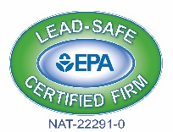

**General Specifications for all**

**Weatherization Contractor Tasks**

Specifications Applicable to ALL Tasks

* **OUR HCR FORMS #24, 28 & OUR TERMS / CONDITIONS NEED TO BE SUBMITTED WITH THIS ANNUAL BID.**
* All work is to comply with state and local building codes and applicable local building permits.
* This bid is for Weatherization jobs.
* Bids will be awarded to winning contractors on a per measure basis
* Contractor is to make an effort for minimal disturbance to occupants.
* Contractor shall clean up all debris and disturbances at no additional cost to the agency or

 Occupants.

1. **The contractor shall supply all materials, labor, and equipment necessary to complete the work and make it whole. All change orders must have WAP authorization prior to installation.**

All services are to be provided in a polite and workmanlike manner.

1. Any additional work deemed necessary by the contractor must be approved by the agency through

The use of a signed change order.

1. The agency is to be notified immediately of any circumstances that exist where work cannot be

Performed due to issues such as potential safety problems or potential for damage to the home.

An installation date must be arranged within 1 business day and work must commence within **10** working days from the time we issue a work order. . Any change orders must have WAP authorization prior to installation.

The agency reserves the right to reject any and all bids

All work will be inspected by this agency. Payment will be withheld until deficiencies have been corrected.

**General Specifications**

**Quotations must be typewritten or written in ink, and corrections must be initialed. Penciled bids will not be accepted.**

Late bids will only be accepted when the Authorized Representatives approve the request for an extension prior to the due date. Otherwise, late bids will not be considered.

Omissions and Discrepancies - If a Bidder is in doubt as to the correct meaning of any part of the specifications or discover any omissions or discrepancies therein; the bidder should notify the appropriate authorized representative. Additional information, when required, will be issued in the form of an addendum which will be sent to all Bidders. Addendums will become part of the initial Bid Request.

Prices quoted will be in effect through May 31, 2025.

Submittals will be required to be reviewed by HCR representative and may result in removal of awarded bidder.

**Warranty**

The supplier warrants to Purchaser that the product will be new and not refurbished.

The supplier warrants to Purchaser that the product will be free from defects and will meet the product specifications stated.

**Execution of Contract/Rejection of Bids**

NHS of South Buffalo Weatherization reserves the right to:

* Reject any/or all bids
* Adapt all or any part of the Bid in selecting optimal product specifications

**Non-Discrimination/Equal Opportunity**

Discrimination against any individual, for reason of race, creed, national origin, sex, handicap or age is specifically prohibited.

**City of Buffalo Permit and any other applicable Permits/Certifications as may be required by the City of Buffalo Licensing Division**

**ALL INVOICES MUST INCLUDE:**

* **Name & Address of work order**
* **Number of workers & total hours worked onsite**
* **Material used, Notes & pictures**
* **Cost of permit (where applicable)**
* **ALL INVOICES ARE TO BE SENT TO:**

[**billing@nhssouthbuffalo.org**](mailto:billing@nhssouthbuffalo.org)

**Instructions:** Carefully read the terms and conditions shown above before preparing your proposals. Please sign on lines below indicating that you have read each page of this Bid Package thoroughly and agree to all specifications, **terms and conditions**. **Bids will not be accepted if incomplete.**

|  |  |
| --- | --- |
| Vendor Name: |  |
| Contact Person Regarding Bid:  (please print clearly) |  |
| E-Mail Address: |  |
| Phone/Fax Number: |  |
| Customer Service(order taker)  (please print clearly) | Name:  Phone: |
| Signature of Authorized Rep: |  |
| Printed Name and Title of Signor: |  |

**Specifications & Bid Form**

**Supply & install a flexible aluminum chimney**:

* **OUR HCR FORMS #24, 28 & OUR TERMS / CONDITIONS NEED TO BE SUBMITTED WITH THIS ANNUAL BID.**
* Please note the change on our invitation to bid: State bidding rules now require that all successful bidders must have: “at least one employee on staff that has successfully completed the (8 hour) “lead safety for renovation repair & painting” course. Proof of certification must now be provided to this agency before signing a contract to perform any work.
* Supply & install a 4” or 5” flexible chimney liner for an orphaned water heater
* Include new 26 gauge vent connector to water heater
* After new liner has been installed, drill a ¼” test hole in new vent connector. Test & record water heater draft.
* Copies of tested draft, must be included with invoice for payment (Invoice must be separated Labor / Material)
* An installation date must be arranged within 1 business day and work must commence within **10** working days from the time we issue a work order. There are no minimum or maximum number of chimney liner installations for this bid.

Install 4” Liner 25’ Length - Material. $ _________ / Labor $ ____________

Install 5” Liner 25’ Length - Material. $ __________/ Labor $ ____________

Install 4” Liner 35’ Length- Material $__________ / Labor $ ____________

Install 5” Liner 35’ Length- Material $__________ / Labor $ ____________

Hourly rate for extras (no overtime) $ ________/per hr.

Note: Any extras must have WAP authorization / change order prior to installation.

SOLICITATION OF ANY WORK OUTSIDE OF WEATHERIZATION SPECIFICATIONS IS PROHIBITED. AND WILL RESULT INTERMINATION OF THIS CONTRACT AND PARTICIPATION OF ANY OTHER BIDS.

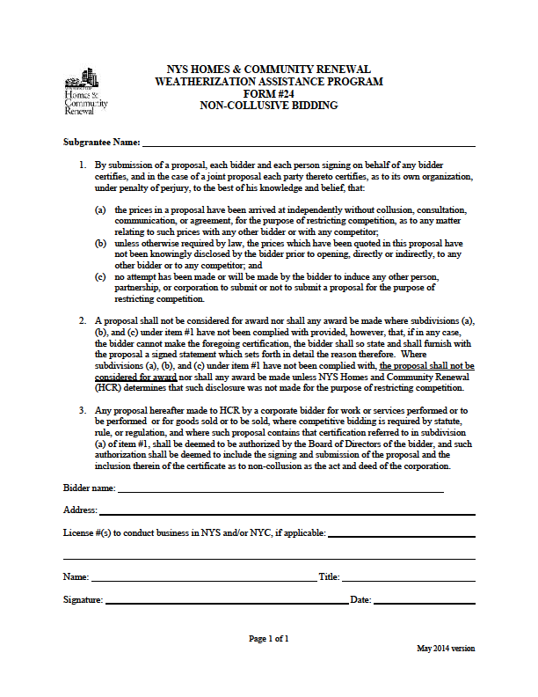Page 1 o

**NYS HOMES AND COMMUNITY RENEWAL**

**WEATHERIZATION ASSISTANCE PROGRAM**

**HCR # 28**

**CONTRACTOR QUALIFICATION**

The following information must be completed in order to be considered a qualified bidder.

**I**

**Bidder Information**

Legal Company Name

D/B/A

Address City State Zip Code Telephone

**II**

**Company Structure**

❑ Corporation ❑ Partnership ❑ Individual ❑ Other

If “Other,” explain:

State of Incorporation or Registration Number Number of Years in Business

**III**

**Principals**

List the name, address, telephone number and position of each principal of the company. (Attach additional pages if necessary.) "Principal" means

each officer and director of the bidder and each shareholder, partner and co-venturer who either controls or owns, directly or indirectly, a ten percent or greater interest in the bidder or who will actively participate in the performance by the bidder of the proposed contract.

|  |  |  |  |
| --- | --- | --- | --- |
| Name | Address | Phone # | Position |
|  |  | ( ) |  |
|  |  | ( ) |  |
|  |  | ( ) |  |
|  |  | ( ) |  |

Which licenses does your company hold?

❑ Plumbing #                                Issued by:                                                                                       Date:

❑ Electrical #                                 Issued by:                                                                                       Date:

❑ Other #                                 Issued by:                                                                                       Date:

If none, please explain:

**IV**

**Bank Reference**

Bank

Address City State Zip Code Telephone

Account Name                                                Account #:                                                   Contact Person:

**V**

**Woman/Minority-Owned Business**

Is this a woman or minority-owned business? ❑ Yes ❑ No

If “Yes,” is it qualified as such with the State of New York? ❑ Yes ❑ No Certification #:

**VI**

**Disqualification**

Has this business, its individuals, partners, officers and/or shareholders . . .

(a) been disbarred or otherwise disqualified from participation in city, state or federally funded work projects? ❑ Yes ❑ No

If “Yes,” please give details:

**VII**

**Affiliation**

List all other businesses in which the majority owners, partners, officers and shareholders have held an affiliation or interest in the past five years.

(Attach additional pages if necessary.)

|  |  |  |  |  |
| --- | --- | --- | --- | --- |
| Name of Business | Address | Work/Service Performed | Contact Person | Phone # |
|  |  |  |  | ( ) |
|  |  |  |  | ( ) |
|  |  |  |  | ( ) |

**VIII**

**WAP History**

List all Weatherization Assistance Program (WAP) subgrantees for which you completed major heating system work during the past three years: (Attach additional pages if necessary.)

|  |  |
| --- | --- |
| Subgrantee Name | Subgrantee Name |
|  |  |
|  |  |
|  |  |

**IX**

**Insurance**

Insurance Company

Address City State Zip Code

Type of Coverage:                                         $ Amount:                                Contact Person:                                      Telephone:                               Are there any claims pending against your auto/general contractor liability coverage? ❑ Yes ❑ No

If “Yes,” amount of claim(s) $                      $                      $                      $

Bonding Company

Address City State Zip Code

Contact Person:                                                                                             Telephone:

**X**

**Project History**

Complete the following information for each of the last five heating replacement projects of 25+ units completed by your organization:

|  |  |  |
| --- | --- | --- |
| Owner/Project Name | | |
| Address | | |
| Contact Person | Phone # | Cost of Project |
| Did you subcontract any portion of the contract work? ❑ Yes ❑ No | | |
| If so, approximately how much of the work did you subcontract? | | |
| Name of Subcontractor Description of Subcontracted Work | | |

|  |  |  |
| --- | --- | --- |
| Owner/Project Name | | |
| Address | | |
| Contact Person | Phone # | Cost of Project |
| Did you subcontract any portion of the contract work? ❑ Yes ❑ No | | |
| If so, approximately how much of the work did you subcontract? | | |
| Name of Subcontractor Description of Subcontracted Work | | |

|  |  |  |
| --- | --- | --- |
| Owner/Project Name | | |
| Address | | |
| Contact Person | Phone # | Cost of Project |
| Did you subcontract any portion of the contract work? ❑ Yes ❑ No | | |
| If so, approximately how much of the work did you subcontract? | | |
| Name of Subcontractor Description of Subcontracted Work | | |

|  |  |  |
| --- | --- | --- |
| Owner/Project Name | | |
| Address | | |
| Contact Person | Phone # | Cost of Project |
| Did you subcontract any portion of the contract work? ❑ Yes ❑ No | | |
| If so, approximately how much of the work did you subcontract? | | |
| Name of Subcontractor Description of Subcontracted Work | | |

|  |  |  |
| --- | --- | --- |
| Owner/Project Name | | |
| Address | | |
| Contact Person | Phone # | Cost of Project |
| Did you subcontract any portion of the contract work? ❑ Yes ❑ No | | |
| If so, approximately how much of the work did you subcontract? | | |
| Name of Subcontractor Description of Subcontracted Work | | |

**XI**

**Affirmation**

By submission of this application, the applicant and person signing on behalf of any applicant subscribes and affirms, under penalties of law, that the statements made in this application for inclusion to the Qualified Bidders List have been examined and to the best of his/her knowledge and belief are true and correct. The applicant affirms that no person named in this application is subject to disqualification under the terms and guidelines of New York City and New York State unless herein stated. The applicant understands that by signing this application it consents to any other inquiry to verify or confirm the information given herein. The applicant understands that this application for inclusion on the Qualified Bidders List does not guarantee that inclusion will be granted but will be used in the determination of eligibility for inclusion.

(Signature)

(Print Name)

(Title)

TO BE COMPLETED BY NOTARY

*(in accordance with State notary requirements)*

State of _____________________________

County of ___________________________

This instrument was acknowledged before me this _____day of _____________ (month), _________ (year), by___________________________________________ (name of officer or agent, title or officer or agent) of _________________________________ (name of entity).

_____ Personally Known

_____ Produced Identification

Type of ID and Number on ID ____________________________

(Seal)

________________________

Signature of Notary

____________________________

Name of Notary

(Typed, Stamped or Printed)

Notary Public, State of _______________