
 Neighborhood Housing Services of South Buffalo, Inc.
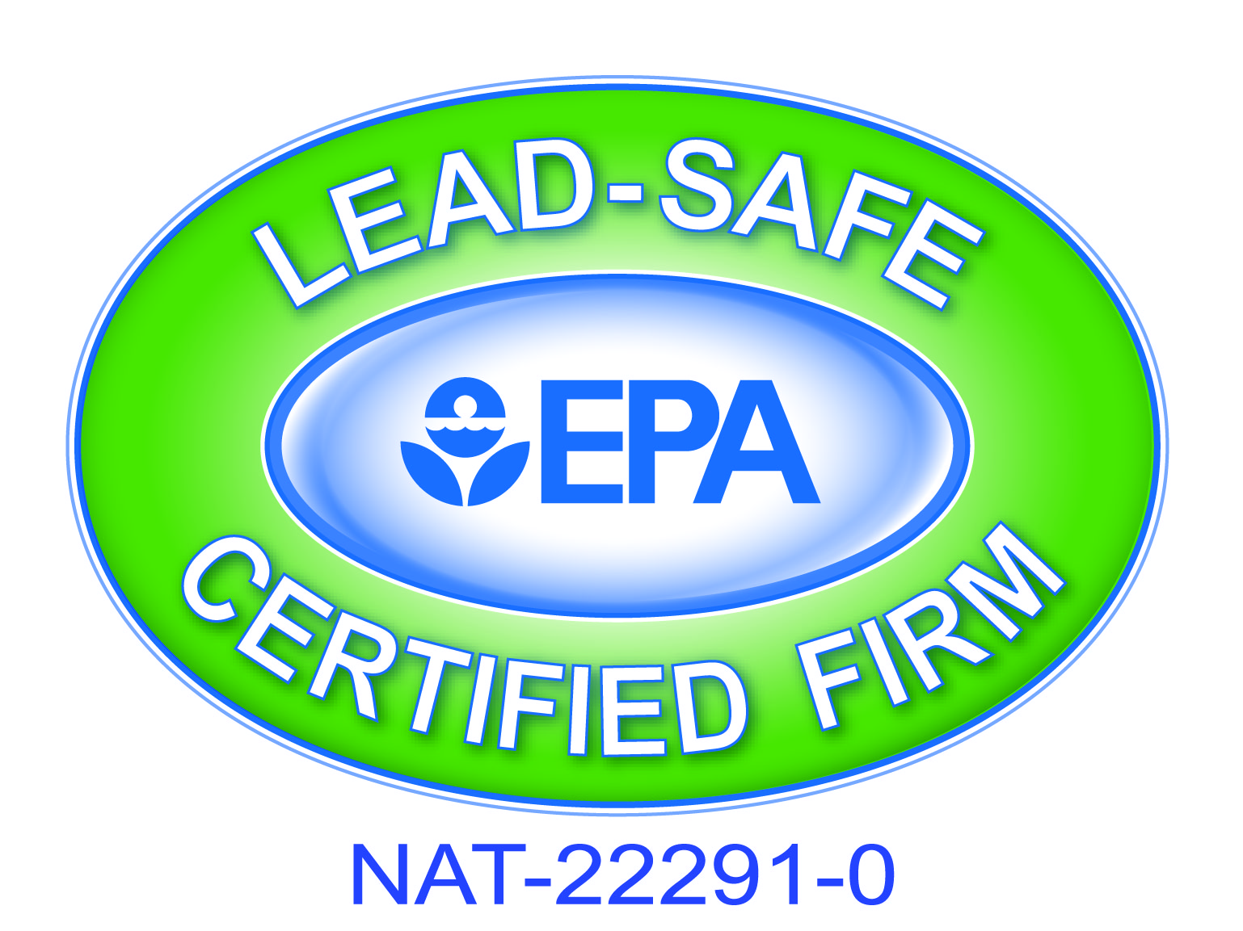1937 South Park Ave. • Buffalo, NY 14220 • Phone: 716.823.3630 • Fax: 716.823.2967
www.nhssouthbuffalo.org • email: info@nhssouthbuffalo.org
Weatherization Assistance Program
95 Dorothy St. • Buffalo, NY 14206 • Phone: 716.837-0071 • Fax: 716.837.0244
email: info@nhssouthbuffalo.org

May 3, 2024

Dear Representative,

The Neighborhood Housing Services (NHS) of South Buffalo, Inc. as part of their Weatherization Assistance Program is soliciting an invitation to bid for the attached specifications.

ANNUAL BID: Plumbing / Gas Fired, Power Vented DHWT Installation Contract Ending May 31, 2025

Please be aware that the City of Buffalo requires that all contractors working within the municipal boundaries must be licensed by the City of Buffalo. No building permit is needed for the installation of insulation; however, “Lead Renovator” work practice certification is required for State bidding requirements. Should you have any questions concerning any permit requirements for the City of Buffalo, you can call the Permit Division at 851-4932.

NOTE: This bid is for the Weatherization program. These bid prices will stay in effect until the end of the weatherization contract March 31, 2023.

Also enclosed are our forms (#24, #28, & our terms & conditions). #24 & our terms / conditions are required to be completed and returned with every bid. (#28 only needs to be submitted once per year.) Please mail or deliver sealed bids by 3:45 pm on Friday May 17, 2024 to:

NHS of South Buffalo – W.A.P.
95 Dorothy St.
Buffalo, New York 14206

A bid opening will be performed at 4:00 pm on Friday, May 17, 2024 at the said office located at 95 Dorothy Street, Buffalo, NY

Upon approval of the bid process by the weatherization agency and the NYS DHCR authorized representative, additional required forms or documentation (i.e, Contractor Sub-agreement, Additional Insured lose payee evidence, etc.) will be required for completion of the award.

Any questions regarding the bid process and/or forms please call 837-0071 Monday through Friday from 8:00 am to 4:00 pm or email to info@nhssouthbuffalo.org .

Sincerely,

Shyrl L. Duderwick
Executive Director

Enclosures – NYS HCR Form # 24, #28

General Specifications

Quotations must be typewritten or written in ink, and corrections must be initialed. Penciled bids will not be accepted.

Late bids will only be accepted when the Authorized Representatives approve the request for an extension prior to the due date. Otherwise, late bids will not be considered.

Proposals should be sent to:

NHS of South Buffalo- WAP
95 Dorothy St.
Buffalo, NY 14206

Omissions and Discrepancies - If a Bidder is in doubt as to the correct meaning of any part of the specifications or discover any omissions or discrepancies therein; the Bidder should notify the appropriate Authorized Representative. Additional information, when required, will be issued in the form of an addendum which will be sent to all Bidders. Addendums will become part of the initial Bid Request.

Firm-fixed price

The quoted prices will be in effect until March 31, 2024. If for any reason pricing can not be met during the contract year a written notice must be submitted in detail. Submittals will be required to be reviewed by HCR representative and may result removal of awarded bidder.

Warranty

The supplier warrants to Purchaser that the product will be new and not refurbished.

The supplier warrants to Purchaser that the product will be free from defects and will meet the product specifications stated.

Damaged or defective items, in the opinion of the Authorized Representatives/Purchasers, shall be replaced at no cost (including shipping) to the Authorized Representatives/Purchasers.

The contractor shall supply all materials, labor, and equipment necessary to complete the work and make it whole. Work must commence as per #33 Subcontractor Agreement which will be issued for every job. All change orders must have WAP authorization prior to installation.

Returned Goods Policy

All incorrect/damaged/unwanted goods within a reasonable time frame will be returned to the Vendor in an expeditious manner.

Returns on all incorrect/damaged items will be at the expense of the vendor. (Includes handling, shipping and delivery charges) There will be no restocking charge.

Execution of Contract/Rejection of Bids

NHS of South Buffalo Weatherization reserves the right to:

- Reject any/or all bids

- Re-bid within a contract year

- Waive or modify minor irregularities in proposal received after prior notification and concurrence of the Bidder

- Adapt all or any part of the Bid in selecting optimal product specifications

Non-Discrimination/Equal Opportunity

Discrimination against any individual, for reason of race, creed, national origin, sex, handicap or age is specifically prohibited.

Instructions: Carefully read the terms and conditions shown above before preparing your proposals. Please sign on lines below indicating that you have read each page of this Bid Package thoroughly and agree to all specifications, terms and conditions. Bids will not be accepted if incomplete.

Contractor Name:
Contact Person Regarding Bid:
(please print clearly)
E-Mail Address:
Phone/Fax Number:
Signature of Authorized Rep:
Printed Name and Title of Signor:

General Specifications for Plumbing Package Bid Solicitation

Weatherization Contractor Tasks

Specifications Applicable to ALL Tasks
- All work is to comply with state and local building codes and applicable local building permits.
- This bid is for Weatherization jobs.
- Bids will be awarded to winning contractors on a per measure basis
- Contractor must submit proof of being a licensed plumber in City of Buffalo
- Contractor must submit proof of at least (1) one EPA “Lead Renovator” Certified employee on staff
- Contractor is to make an effort for minimal disturbance to occupants.
- Contractor shall clean up all debris and disturbances at no additional cost to the agency or
Occupants.

All services are to be provided in a polite and workmanlike manner.
- Any additional work deemed necessary by the contractor must be approved by the agency through
The use of a signed change order.
- The agency is to be notified immediately of any circumstances that exist where work cannot be
Performed due to issues such as potential safety problems or potential for damage to the home.
An installation date must be arranged within 1 business day and work must commence within 5 working days from the time we issue a work order. . Any change orders must have WAP authorization prior to installation.

The agency reserves the right to reject any and all bids

To replace existing residential, natural draft, gas fired storage type water heaters.
Include labor and materials in all items listed below. Base hourly rate is for items not listed.
All required materials are to be on hand at time of installation.

1. With a 40 gallon; gas fired; power vented DHWT with all necessary gas piping and PVC venting*
If 110 v receptacle is within 5 ft of tank, $ _________/item

2. If 110 v receptacle is not within 5 ft of tank location $ _________/item

3. Install missing or replace a non-functioning c/w supply valve $__________/item

4. Base Hourly Rate $ _________/hr.

*Include: new gas cock & max 5ft of ½” gas pipe; cold water isolation valve & max 3’ hot & cold water lines. PVC venting as required. & as per manufacturer’s instructions.
* Installation of DHWT must be tested and documented for carbon monoxide level at vent pipe termination; all results must be submitted to NHS weatherization. Contractor must register new tank on line for full manufacturers’ warranty. Deliver copies of registration to NHS & homeowner. Instruct client on operation procedures and warranties. Remove old DHWT and any debris from premises.

Contractor must install per manufacturer’s instructions and cover the manufacturer’s warranty.
Contractor also warrantees all parts and labor for 1 yr.

Successful bidder must be licensed by the city of Buffalo licensing division.

A permit is required for each water heater installation. A copy of all permits, test data & warranty registrations filed must be submitted to NHS Weatherization Inc. prior to receiving payment of completed work. *** Permits are now available instantly on-line at city of buffalo website / permits

Prices quoted will be in effect through May 31,2025.

An installation date must be arranged within 1 business day and work must commence within 5 working days from the time we issue a work order.
Any change orders must have WAP authorization prior to installation.

Please note the change on our invitation to bid: State bidding rules now require that all successful bidders must have at least one employee on staff that has successfully completed the (8 hour) “lead safety for renovation repair & painting” course. Proof of certification must now be provided to this agency before signing a contract to perform any work.

INVOICING:
All invoicing must include the following:
- Bid price separated Material & Labor
- Customers name, address
- Dates worked performed
- Any photos , LSW sheets , notes
- Copy of permit filed with City of Buffalo
- List of materials used, MSDS sheets- (if same products are used throughout year one copy of all MSDS sheets are needed prior to first work order issued)
- ALL INVOICES SENT TO:
Billing@nhssouthbuffalo.org

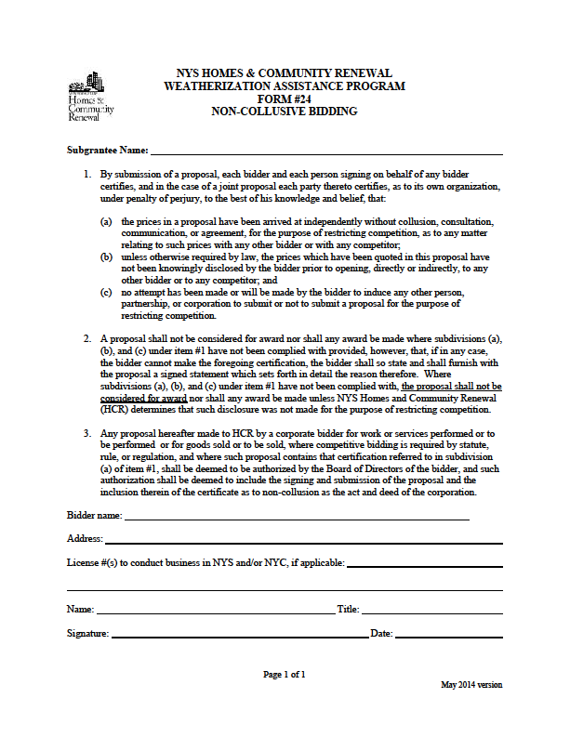

NYS HOMES AND COMMUNITY RENEWAL
WEATHERIZATION ASSISTANCE PROGRAM
HCR # 28

CONTRACTOR QUALIFICATION
The following information must be completed in order to be considered a qualified bidder.

I
Bidder Information

Legal Company Name

D/B/A

Address City State Zip Code Telephone

II
Company Structure

❑ Corporation  Partnership  Individual  Other
If “Other,” explain:

State of Incorporation or Registration Number Number of Years in Business

III
Principals

List the name, address, telephone number and position of each principal of the company. (Attach additional pages if necessary.) "Principal" means
each officer and director of the bidder and each shareholder, partner and co-venturer who either controls or owns, directly or indirectly, a ten percent or greater interest in the bidder or who will actively participate in the performance by the bidder of the proposed contract.

Name | Address | Phone # | Position
 |  | ( )
 |  | ( )
 |  | ( )
 |  | ( )
Which licenses does your company hold?
❑ Plumbing # Issued by: Date:

❑ Electrical # Issued by: Date:

❑ Other # Issued by: Date:

If none, please explain:

IV
Bank Reference

Bank

Address City State Zip Code Telephone

Account Name Account #: Contact Person:
V
Woman/Minority-Owned Business

Is this a woman or minority-owned business?  Yes  No
If “Yes,” is it qualified as such with the State of New York?  Yes  No Certification #:

VI
Disqualification
Has this business, its individuals, partners, officers and/or shareholders . . .
(a) been disbarred or otherwise disqualified from participation in city, state or federally funded work projects?  Yes  No
If “Yes,” please give details:

VII
Affiliation

List all other businesses in which the majority owners, partners, officers and shareholders have held an affiliation or interest in the past five years.
(Attach additional pages if necessary.)
Name of Business | Address | Work/Service Performed | Contact Person | Phone #
 |  |  |  | ( )
 |  |  |  | ( )
 |  |  |  | ( )

VIII
WAP History

List all Weatherization Assistance Program (WAP) subgrantees for which you completed major heating system work during the past three years: (Attach additional pages if necessary.)
Subgrantee Name | Subgrantee Name

IX
Insurance

Insurance Company

Address City State Zip Code

Type of Coverage: $ Amount: Contact Person: Telephone: Are there any claims pending against your auto/general contractor liability coverage?  Yes  No

If “Yes,” amount of claim(s) $ $ $ $

Bonding Company

Address City State Zip Code

Contact Person: Telephone:

X
Project History
Complete the following information for each of the last five heating replacement projects of 25+ units completed by your organization:
Owner/Project Name
Address
Contact Person | Phone # | Cost of Project
Did you subcontract any portion of the contract work?  Yes  No

If so, approximately how much of the work did you subcontract?

Name of Subcontractor Description of Subcontracted Work

Owner/Project Name
Address
Contact Person | Phone # | Cost of Project
Did you subcontract any portion of the contract work?  Yes  No

If so, approximately how much of the work did you subcontract?

Name of Subcontractor Description of Subcontracted Work

Owner/Project Name
Address
Contact Person | Phone # | Cost of Project
Did you subcontract any portion of the contract work?  Yes  No

If so, approximately how much of the work did you subcontract?

Name of Subcontractor Description of Subcontracted Work

Owner/Project Name
Address
Contact Person | Phone # | Cost of Project
Did you subcontract any portion of the contract work?  Yes  No

If so, approximately how much of the work did you subcontract?

Name of Subcontractor Description of Subcontracted Work

Owner/Project Name
Address
Contact Person | Phone # | Cost of Project
Did you subcontract any portion of the contract work?  Yes  No

If so, approximately how much of the work did you subcontract?

Name of Subcontractor Description of Subcontracted Work

XI
Affirmation

By submission of this application, the applicant and person signing on behalf of any applicant subscribes and affirms, under penalties of law, that the statements made in this application for inclusion to the Qualified Bidders List have been examined and to the best of his/her knowledge and belief are true and correct. The applicant affirms that no person named in this application is subject to disqualification under the terms and guidelines of New York City and New York State unless herein stated. The applicant understands that by signing this application it consents to any other inquiry to verify or confirm the information given herein. The applicant understands that this application for inclusion on the Qualified Bidders List does not guarantee that inclusion will be granted but will be used in the determination of eligibility for inclusion.

(Signature)

(Print Name)

(Title)
TO BE COMPLETED BY NOTARY
(in accordance with State notary requirements)

State of _____________________________
County of ___________________________

This instrument was acknowledged before me this _____day of _____________ (month), _________ (year), by___________________________________________ (name of officer or agent, title or officer or agent) of _________________________________ (name of entity).

_____ Personally Known

_____ Produced Identification

Type of ID and Number on ID ____________________________

(Seal)
________________________
Signature of Notary

____________________________
Name of Notary
(Typed, Stamped or Printed)

Notary Public, State of _______________

