
 Neighborhood Housing Services of South Buffalo, Inc.
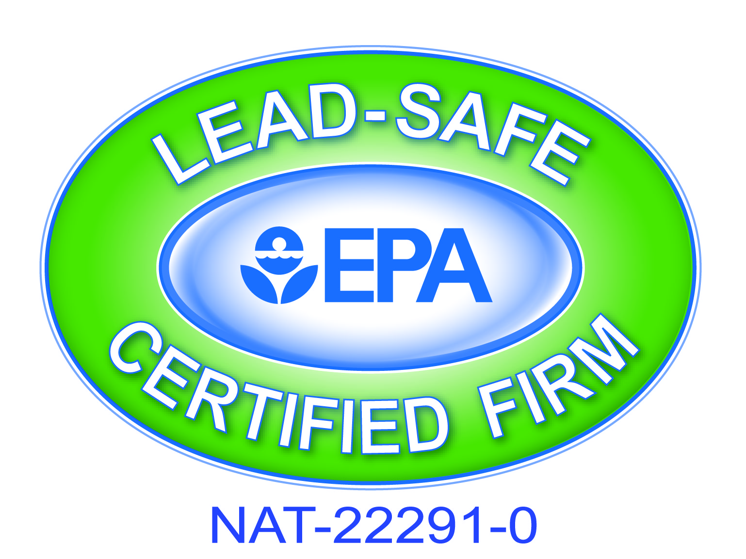

May 3, 2024

Dear Representative,

The Neighborhood Housing Services (NHS) of South Buffalo, Inc. as part of their Weatherization Assistance Program is soliciting an invitation to BID for the attached specifications.
PLEASE READ BELOW
This annual procurement solicitation is to procure an annual bid for the installation of furnaces that operate with a FIXED SPEED CONSTANT TORQUE BLOWER MOTOR.

Please be aware that the City of Buffalo requires that all contractors working within the municipal boundaries must be licensed by the City of Buffalo. Should you have any questions concerning any permit requirements for the City of Buffalo, you can call the Permit Division at 851-4932.
Also, “Lead Renovator” work practice certification is required for State bidding.
NOTE: This bid is for a Weatherization Assistance Program project.

Also enclosed are our forms (#24, #28, #2, #10 & our terms & conditions).
OUR HCR FORMS #24, 28 & OUR TERMS / CONDITIONS NEED TO BE SUBMITTED WITH EVERY ANNUAL BID.
Please mail or deliver sealed bids by 3:45 pm on Friday May 17,2024to:

NHS of South Buffalo – W.A.P.
95 Dorothy St.
Buffalo, New York 14206

A bid opening will be performed at 4:00 pm on Friday May 3, 2024 at the said office located at 95 Dorothy St, Buffalo, NY

Upon approval of the bid process by the weatherization agency and the NYS HCR authorized representative, additional required forms or documentation (i.e., Contractor Sub-agreement, Additional Insured lose payee evidence, etc.) will be required for completion of the award.

Any questions regarding the bid process and/or forms please call 837-0071 Monday through Friday from 8:00 am to 4:00 pm or email to info@nhssouthbuffalo.org .

Sincerely,

Shyrl L. Duderwick
Executive Director

Enclosures – NYS HCR Form # 24, 28, 2 & 10

1937 South Park Ave. • Buffalo, NY 14220 • Phone: 716.823.3630 • Fax: 716.823.2967
+
www.nhssouthbuffalo.org • email: info@nhssouthbuffalo.org

Weatherization Assistance Program
95 Dorothy St. • Buffalo, NY 14206 • Phone: 716.837-0071 • Fax: 716.837.0244
Email: info@nhssouthbuffalo.org

Our Terms, Conditions
& General Specifications for all
Weatherization Contractor Tasks

Specifications Applicable to ALL Tasks
- OUR HCR FORMS #24, 28 & OUR TERMS / CONDITIONS NEED TO BE SUBMITTED WITH THIS ANNUAL BID.
- All work is to comply with state and local building codes and applicable local building permits.
- This bid is for Weatherization jobs.
- Bids may be awarded to winning contractors on a per measure or cumulative basis to be determined by NHS
- Contractor must submit proof of being a licensed heating contractor in the City of Buffalo
- Contractor must submit proof of at least (1) one EPA “Lead Renovator” Certified employee on staff
- Contractor is to make an effort for minimal disturbance to occupants.
- Contractor shall clean up all debris and disturbances at no additional cost to the agency or
Occupants.
- The contractor shall supply all materials, labor, and equipment necessary to complete the work and make it whole. Work must commence as per #33 Subcontractor agreement, which will be issued for every job.
- All change orders must have WAP authorization prior to installation.
- The agency is to be notified immediately of any circumstances that exist where work cannot be
Performed due to issues such as potential safety problems or potential for damage to the home.

Solicitation of Work from NHS Clients:
Any solicitation of our clients for extra work will not be tolerated & will result in dismissal from our qualified bidders list. However, HVAC contractors must post their name & phone number near the new heating equipment, clearly identifying themselves as the installer. Any existing tags from previous contractors are to be left intact.

General Specifications
Quotations must be typewritten or written in ink, and corrections must be initialed. Penciled bids will not be accepted.
Late bids will only be accepted when the Authorized Representatives approve the request for an extension prior to the due date. Otherwise, late bids will not be considered.
Omissions and Discrepancies - If a Bidder is in doubt as to the correct meaning of any part of the specifications or discover any omissions or discrepancies therein; the bidder should notify the appropriate authorized representative. Additional information, when required, will be issued in the form of an addendum which will be sent to all Bidders. Addendums will become part of the initial Bid Request.
Submittals will be required to be reviewed by HCR representative and may result in removal of awarded bidder. The successful bidder will receive individual notification for each furnace replacement. An installation date must be arranged within 1 business day and work must commence within 10 working days from the time we issue a work order. If unable to meet the 10 day time frame for that job, immediately notify this agency in writing.
Any change orders must have WAP authorization prior to installation.
Warranty
The supplier warrants to Purchaser that the product will be new and not refurbished.
The supplier warrants to Purchaser that the product will be free from defects and will meet the product specifications stated.
HVAC contractors will include a full one year parts & labor warranty

Execution of Contract/Rejection of Bids
NHS of South Buffalo Weatherization reserves the right to:
- Reject any/or all bids
- Lowest bid is not necessarily the winning bid
- Adapt all or any part of the bid in selecting optimal product specifications
- All work will be inspected by this agency. Payment will be withheld until deficiencies have been corrected.

Non-Discrimination/Equal Opportunity
Discrimination against any individual, for reason of race, creed, national origin, sex, handicap or age is specifically prohibited.

Instructions: Carefully read the terms and conditions shown above before preparing your proposals. Please sign on lines below indicating that you have read each page of this Bid Package thoroughly and agree to all specifications, terms and conditions. Bids will not be accepted if incomplete.

INVOICING:
All invoicing must include the following:
- Dates worked performed / Bid price separated Material & Labor / Customer’s name & address
- Copies of tested combustion analysis, City of Buffalo heating permit, manufacturer’s warranty registration, LSW forms for replacing furnace & drilling holes in painted walls
- List of materials used, MSDS sheets- (if same products are used throughout year one copy of all MSDS sheets are needed prior to first work order issued)
- ALL INVOICES TO BE SENT TO :
Billing@nhssouthbuffalo.org

Vendor Name:
Contact Person Regarding Bid:
(please print clearly)
E-Mail Address:
Phone/Fax Number:
Customer Service(order taker)  (please print clearly) | Name:  Phone:
Signature of Authorized Rep:
Printed Name and Title of Signor:

Our Specifications and Bid Form

Prices quoted will be in effect through May 31, 2025. An installation date must be arranged within 1 business day and work must commence within 10 working days from the time we issue a work order. There is no minimum or maximum number of furnace replacements for this bid.
Our HCR forms #24, 28 & our terms / conditions need to be submitted with this annual bid.
A permit is required for each furnace installation & a copy of all permits filed must be submitted to NHS Weatherization Inc. prior to receiving payment of completed work.

The following specification is thorough & represents a repetitive, slip-under type of application. No extras will be allowed unless authorized by NHS representative. If any job exceeds our specification, it will skip this procurement contract and a formal bid solicitation will be issued for that project.

To replace existing residential, gas fired heating appliances as follows:
1. Supply & install a gas fired, forced air furnace:
Min. 95% AFUE ; single stage gas valve; fixed speed - constant torque blower motor; c/w direct vent 2 pipe system with concentric or flush mounted wall kit.**
Include the following:
- New return air drop & filter boot w/ sealed filter slot. Completely seal all seams inside new blower compartment & “buffalo boot” with 2” foil tape
- Minimum drop sizes: <= 60,000 btuh : 20x8; <=80,000 btuh: 24x8; <=120,000 btuh: 24x10
- Install a 1” pleated filter. Minimum acceptable filter size is 20x20, or greater if recommended by furnace manufacturer.
- Proper transition to existing supply plenum.
- Condensate pump; programmable thermostat; safety kill switch
- All line & low voltage wiring & all gas piping within 5 ft radius of furnace. Include new gas cock
- Ensure that proper ground exists for new furnace
- Combination carbon monoxide & smoke detector (hard wired) with a lithium back up battery
- Seal old openings in chimney
- Perform lead safe work practices for removal of old furnace & drilling holes in painted walls
- All piping to be properly installed / supported
- All work to be performed in a professional, tradesman like manor. All manufacturers’ instructions, local & national codes are to be followed
- Any extra work with our clients is not allowed & can result in termination of contract
- Properly remove & dispose of old furnace. Old equipment may not remain at that address
- Test & record temp rise for new furnace. Advise this agency if not within manufacturers specs
- Test & record combustion analysis for new furnace
- Instruct client on operating procedures and warranties
- Contractor to register new equipment with manufacturer for full warranty & deliver copies to homeowner & NHS
- Copies of tested combustion analysis, City of Buffalo heating permit, manufacturer’s warranty registration, LSW forms for replacing furnace & drilling holes in painted walls must be included with invoice for payment
- Include one year parts & labor warranty
- ** Location of vent termination on exterior wall is not necessarily the shortest run. All termination points are to be approved by homeowner & this agency
- *** Permits are now available instantly on-line at city of buffalo website / permits

Bid Form

Prices for lines 1, 2 & 3 will be looked at individually.
1. Furnaces having an input between 40,000 to 80,000 btuh** Labor=$__________ Material=$__________Total=$__________

2. Furnaces having an input between 81,000 to 100,000 btuh** Labor=$__________ Material=$__________Total=$__________
3. Furnaces having an input between 101,000 to 120,000 btuh** Labor=$__________Material=$__________Total=$__________
** Include manufacturers spec. with your bid

4. Hourly rate for extras (no overtime) Labor= $__________

Extra Items: (Bidding for any extra items is optional):

A. Extra for replacing a “low boy” style furnace Labor=$__________ Material=$__________

B. Extra for replacing a gravity furnace (Supply: requires a new plenum, re-connect all existing supply branches. Return: provide full return to central floor grille(s))
Labor=$__________ Material=$__________

C. Extra for a no heat emergency installation. (Installed within 24 hours) No portable electric heaters are allowed as temporary heat. Labor=$__________ Material=$__________
D. Oil tank removal (empty) Labor=$__________ Material=$__________

E. Oil tank removal (not empty) Labor=$__________ Material=$__________

*All manufacturers of unitary hvac equipment that meet our specifications are acceptable. The successful bidder may be asked to provide a product submittal or AHRI certificate of performance for equipment being installed.
All heat loss calculations for this structure were performed by our auditors using Targeted Investment Protocol System software as prescribed & provided by NYSDHCR. As per New York State Weatherization Assistance Program Policies & Procedures Manual “a contractor involved in the design of a project may not also be a bidder on said project.’
City of Buffalo Permit and any other applicable Permits/Certifications as may be required by the City of Buffalo Licensing Division.

A permit is required for each furnace installation & a copy of all permits filed must be submitted to NHS Weatherization Inc. prior to receiving payment of completed work.
Prices quoted will be in effect through May 31, 2025. An installation date must be arranged within 1 business day and work must commence within 10 working days from the time we issue a work order. There is no minimum or maximum number of furnace replacements for this bid.
Please note the change on our invitation to bid: State bidding rules now require that all successful bidders must have: “at least one employee on staff that has successfully completed the (8 hour) “lead safety for renovation repair & painting” course. Proof of certification must now be provided to this agency before signing a contract to perform any work. City of Buffalo Permit and any other applicable Permits/Certifications as may be required by the City of Buffalo Licensing Division.

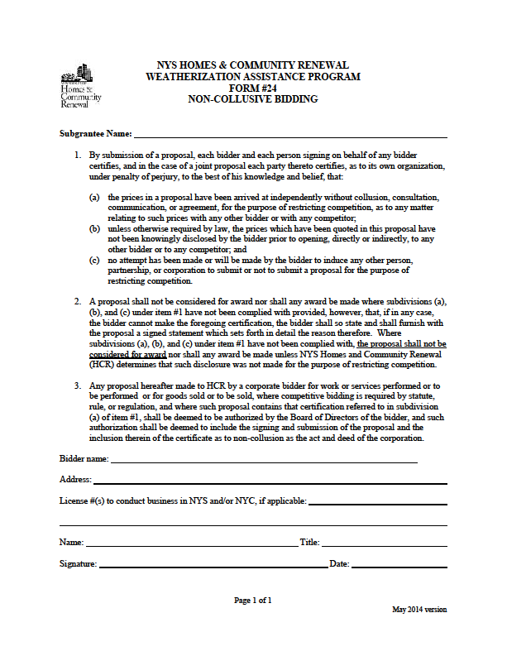

NYS HOMES AND COMMUNITY RENEWAL
WEATHERIZATION ASSISTANCE PROGRAM
HCR # 28

CONTRACTOR QUALIFICATION
The following information must be completed in order to be considered a qualified bidder.

I
Bidder Information

Legal Company Name

D/B/A

Address City State Zip Code Telephone

II
Company Structure

❑ Corporation  Partnership  Individual  Other
If “Other,” explain:

State of Incorporation or Registration Number Number of Years in Business

III
Principals

List the name, address, telephone number and position of each principal of the company. (Attach additional pages if necessary.) "Principal" means
each officer and director of the bidder and each shareholder, partner and co-venturer who either controls or owns, directly or indirectly, a ten percent or greater interest in the bidder or who will actively participate in the performance by the bidder of the proposed contract.

Name | Address | Phone # | Position
 |  | ( )
 |  | ( )
 |  | ( )
 |  | ( )
Which licenses does your company hold?
❑ Plumbing # Issued by: Date:

❑ Electrical # Issued by: Date:

❑ Other # Issued by: Date:

If none, please explain:

IV
Bank Reference

Bank

Address City State Zip Code Telephone

Account Name Account #: Contact Person:
V
Woman/Minority-Owned Business

Is this a woman or minority-owned business?  Yes  No
If “Yes,” is it qualified as such with the State of New York?  Yes  No Certification #:

VI
Disqualification
Has this business, its individuals, partners, officers and/or shareholders . . .
(a) been disbarred or otherwise disqualified from participation in city, state or federally funded work projects?  Yes  No
If “Yes,” please give details:

VII
Affiliation

List all other businesses in which the majority owners, partners, officers and shareholders have held an affiliation or interest in the past five years.
(Attach additional pages if necessary.)
Name of Business | Address | Work/Service Performed | Contact Person | Phone #
 |  |  |  | ( )
 |  |  |  | ( )
 |  |  |  | ( )

VIII
WAP History

List all Weatherization Assistance Program (WAP) subgrantees for which you completed major heating system work during the past three years: (Attach additional pages if necessary.)
Subgrantee Name | Subgrantee Name

IX
Insurance

Insurance Company

Address City State Zip Code

Type of Coverage: $ Amount: Contact Person: Telephone: Are there any claims pending against your auto/general contractor liability coverage?  Yes  No

If “Yes,” amount of claim(s) $ $ $ $

Bonding Company

Address City State Zip Code

Contact Person: Telephone:

X
Project History
Complete the following information for each of the last five heating replacement projects of 25+ units completed by your organization:
Owner/Project Name
Address
Contact Person | Phone # | Cost of Project
Did you subcontract any portion of the contract work?  Yes  No

If so, approximately how much of the work did you subcontract?

Name of Subcontractor Description of Subcontracted Work

Owner/Project Name
Address
Contact Person | Phone # | Cost of Project
Did you subcontract any portion of the contract work?  Yes  No

If so, approximately how much of the work did you subcontract?

Name of Subcontractor Description of Subcontracted Work

Owner/Project Name
Address
Contact Person | Phone # | Cost of Project
Did you subcontract any portion of the contract work?  Yes  No

If so, approximately how much of the work did you subcontract?

Name of Subcontractor Description of Subcontracted Work

Owner/Project Name
Address
Contact Person | Phone # | Cost of Project
Did you subcontract any portion of the contract work?  Yes  No

If so, approximately how much of the work did you subcontract?

Name of Subcontractor Description of Subcontracted Work

Owner/Project Name
Address
Contact Person | Phone # | Cost of Project
Did you subcontract any portion of the contract work?  Yes  No

If so, approximately how much of the work did you subcontract?

Name of Subcontractor Description of Subcontracted Work

XI
Affirmation

By submission of this application, the applicant and person signing on behalf of any applicant subscribes and affirms, under penalties of law, that the statements made in this application for inclusion to the Qualified Bidders List have been examined and to the best of his/her knowledge and belief are true and correct. The applicant affirms that no person named in this application is subject to disqualification under the terms and guidelines of New York City and New York State unless herein stated. The applicant understands that by signing this application it consents to any other inquiry to verify or confirm the information given herein. The applicant understands that this application for inclusion on the Qualified Bidders List does not guarantee that inclusion will be granted but will be used in the determination of eligibility for inclusion.

(Signature)

(Print Name)

(Title)

\TO BE COMPLETED BY NOTARY
(in accordance with State notary requirements)

State of _____________________________
County of ___________________________

This instrument was acknowledged before me this _____day of _____________ (month), _________ (year), by___________________________________________ (name of officer or agent, title or officer or agent) of _________________________________ (name of entity).

_____ Personally Known

_____ Produced Identification

Type of ID and Number on ID ____________________________

(Seal)
________________________
Signature of Notary

____________________________
Name of Notary
(Typed, Stamped or Printed)

Notary Public, State of _______________


LSW Activities Log
10
for Date
Replacing Furnaces

Client Name: Job #
Address: Air Sample #

Crew

Site Supervisor Name:
Print Signature

Initial box for LSW practiced (see steps on back):
- Lay 6-mil plastic 5 feet in all directions, where possible, from furnace base. Secure with tape.
- Lockout/Tag out power to furnace. Shut off all gas or fuel oil.
- Mist the area to be disturbed with the LCD.
- Perform work outside of the breathing zone.
- Detach the ductwork as carefully as possible. Use HEPA vacuum to clean-up dust that falls from the ducts or furnace, as soon as possible, to prevent tracking or spreading the dust as work continues.
- Once the old furnace is detached from the ductwork, use 6-mil poly and durable tape to seal ALL the openings on the furnace BEFORE moving the furnace out of the area.
- HEPA vacuum the accessible portions of the ductwork to minimize the disturbance of dust before installing the new furnace.
- HEPA vacuum and wet wipe surfaces frequently, and after installation.
- Follow procedures for clean up and disposal. (Mist debris prior to rolling up plastic)
Notes:

Tools:

SPECIFIC LEAD-SAFE WORK PRACTICE
Replacing Furnaces
If the furnace is to be replaced and the ductwork is to remain in place it should be noted that the process of disconnecting the old furnace from the duct work and reconnecting the new furnace may disturb lead paint surfaces or loosen lead dust settled in the ducts. Since there can be an appreciable amount of surface area inside the ductwork, considerable amounts of lead dust may have accumulated since the furnace was installed. Lead dust may not only get deposited from the air circulating through the ducts, but it may also accumulate below vent openings in the form of paint chips. If the building was constructed prior to 1978 the following set-up and cleanup procedures are recommended for removal and installation of a new furnace:
- Lay 6-mil plastic 5 feet in all directions, where possible, from furnace base. Secure with tape.
- Lockout/Tag out power to furnace. Shut off all gas or fuel oil.
- Mist the area to be disturbed with the LCD.
- Perform work outside of the breathing zone.
- Detach the ductwork as carefully as possible. Use HEPA vacuum to clean-up dust that falls from the ducts or furnace, as soon as possible, to prevent tracking or spreading the dust as work continues.
- Once the old furnace is detached from the ductwork, use 6-mil poly and durable tape to seal ALL the openings on the furnace BEFORE moving the furnace out of the area.
- HEPA vacuum the accessible portions of the ductwork to minimize the disturbance of dust before installing the new furnace.
- HEPA vacuum and wet wipe surfaces frequently, and after installation.
- Follow procedures for clean up and disposal. (Mist debris prior to rolling up plastic)

Clean Up and Disposal

Protective Clothing and Respirator Cartridges
Disposable suits and gloves must be discarded at the end of the workday by rolling them down onto themselves and disposing of them in the 6-mil plastic disposal bag.
If crewmembers wear any kind of footwear or gloves other than disposable protective clothing, the footwear or gloves must be left in the work area. Footwear or gloves must not be removed from the work area if they cannot be effectively cleaned (leather and fabric are difficult to clean). Footwear and gloves that cannot be cleaned must be disposed of as waste.

Waste
All waste (including bags, construction debris, polyethylene sheeting, protective clothing, respirator cartridges) can be disposed of as regular household waste. Ensure that all construction debris is wrapped and all disposal bags are sealed and kept intact prior to removal from the job site.
Remember that ground plastic must be misted before rolling or folding up and all waste must be removed from the job site at the end of each workday.

Hand Washing Facilities
Hand washing facilities must be supplied to the crew to ensure proper hygiene practices. The intent is to prevent inadvertent lead poisoning from ingestion of lead dust during breaks.

Work Area Shut Down

At the end of each workday the crew must:
- HEPA vacuum and clean the work area.
- Discard all disposable coveralls, gloves, and shoe covers.
- Clean and appropriately store all tools, protective equipment, and respirators.
- Wash hands and face.
- Shower as soon as possible.

Notes:

Initial Observations: Weather, ground conditions, paint (color, number of layers, condition)

Area Setup: Client introduction and instructions to avoid jobsite. This includes children and guests. Work area isolated and secured with barriers and caution tape; other warning signs; plastic on ground (specify distance from building or work area), drop cloths on plants, etc;
- Crew Preparation: Protective clothing, respirators (with P100), air monitoring,
- Tools and Equipment: HEPA Vac, shrouded tools, spray equipment, wetting agent
- Surface Preparation/Techniques: Spray down (front and back), scoring paint surface
- Clean Up and Disposal: HEPA Vac and clean tools and equipment (scaffolding/ladders); spray ground plastic, roll up and place in 6 mil poly bag; vacuum paint chips on ground or surfaces.
- Work Area Shut Down: Remove barriers, caution tape, and any warning signs, wash face/hands

LSW Activities Log
2
for Date
Drilling Holes Through Painted Surfaces
(exterior)

Client Name: Job #
Address: Air Sample #

Crew

Site Supervisor Name:
Print Signature

Initial box for LSW practiced (see steps on back):
- Lay 6-mil plastic on the ground and secure to building with tape. Place the plastic 10 feet out for every 10 feet of wall height. Approved portable trough systems may be used as an alternative.
- Cover all landscaping with plastic.
- Perform work outside of the breathing zone.
- Thoroughly mist area to be drilled with the LCD.
- Drill holes; fill wall cavity, mist holes, and plug with wood plugs.
- HEPA vacuum area and follow procedures for clean up and disposal. (Mist debris prior to rolling up plastic)

Notes:

Tools:

SPECIFIC LEAD-SAFE WORK PRACTICE

Drilling Holes Through Painted Surfaces
When drilling holes through exterior painted surfaces use an auger bit or a hole saw. The use of shroud attachments with a HEPA vacuum is recommended for exterior work and is required for interior work.
- Lay 6-mil plastic on the ground and secure to building with tape. Place the plastic 10 feet out for every 10 feet of wall height. Approved portable trough systems may be used as an alternative.
- Exterior: Cover all landscaping with plastic. Interior: Cover all furniture and heating HVAC vents.
- Perform work outside of the breathing zone.
- Thoroughly mist area to be drilled with the LCD.
- Drill holes, fill wall cavity, mist holes, and plug with wood plugs.
- HEPA vacuum area and follow procedures for clean up and disposal. (Mist debris prior to rolling up plastic)

Clean Up and Disposal

Protective Clothing and Respirator Cartridges
Disposable suits and gloves must be discarded at the end of the workday by rolling them down onto themselves and disposing of them in the 6-mil plastic disposal bag.

If crewmembers wear any kind of footwear or gloves other than disposable protective clothing, the footwear or gloves must be left in the work area. Footwear or gloves must not be removed from the work area if they cannot be effectively cleaned (leather and fabric are difficult to clean). Footwear and gloves that cannot be cleaned must be disposed of as waste.

Waste
All waste (including bags, construction debris, polyethylene sheeting, protective clothing, respirator cartridges) can be disposed of as regular household waste. Ensure that all construction debris is wrapped and all disposal bags are sealed and kept intact prior to removal from the job site.

Remember that ground plastic must be misted before rolling or folding up and all waste must be removed from the job site at the end of each workday.

Hand Washing Facilities
Hand washing facilities must be supplied to the crew to ensure proper hygiene practices. The intent is to prevent inadvertent lead poisoning from ingestion of lead dust during breaks.

Work Area Shut Down

At the end of each workday the crew must:
- HEPA vacuum and clean the work area.
- Discard all disposable coveralls, gloves, and shoe covers.
- Clean and appropriately store all tools, protective equipment, and respirators.
- Wash hands and face.
- Shower as soon as possible.

Notes:

Initial Observations: Weather, ground conditions, paint (color, number of layers, condition)

Area Setup: Client introduction and instructions to avoid jobsite. This includes children and guests. Work area isolated and secured with barriers and caution tape; other warning signs; plastic on ground (specify distance from building or work area), drop cloths on plants, etc;
- Crew Preparation: Protective clothing, respirators (with P100), air monitoring,
- Tools and Equipment: HEPA Vac, shrouded tools, spray equipment, wetting agent
- Surface Preparation/Techniques: Spray down (front and back), scoring paint surface
- Clean Up and Disposal: HEPA Vac and clean tools and equipment (scaffolding/ladders); spray ground plastic, roll up and place in 6 mil poly bag; vacuum paint chips on ground or surfaces.
- Work Area Shut Down: Remove barriers, caution tape, and any warning signs, wash face/hands;

